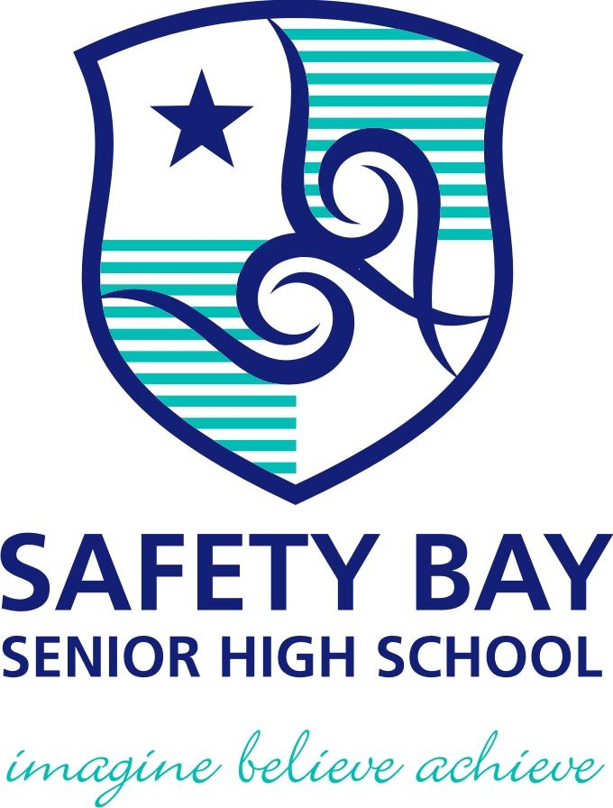

**YEAR: 7**

**2017**

**SUBJECT: Science**

**TEST: Observations, Inferences and Variables**

**TIME: 45 minutes**

**QUESTIONS: 10 Multiple Choice (10 marks)**

**5 Short Answer (31 marks)**

**TOTAL MARKS: 41 marks**

**DO NOT WRITE ON OR MARK THIS PAPER**

**SECTION ONE—MULTIPLE CHOICE** (10 marks)

This section has **10** questions. Answer **all** questions on the separate Multiple-choice Answer Sheet provided.

1. What equipment would measure the volume of a quantity of liquid most accurately?
2. Beaker
3. Test tube
4. Conical flask
5. Measuring cylinder
6. Which statement correctly describes the flame of a Bunsen burner with the **collar closed**?
7. Clean, hot and blue
8. Clean, hot and yellow
9. Smoky, cooler and blue
10. Smoky, cooler and yellow
11. Identify the equipment shown in the scientific drawing below:

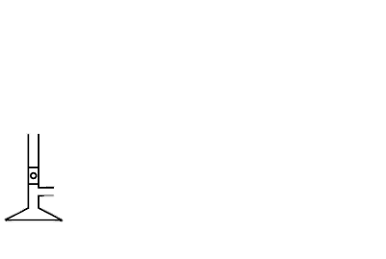

1. Retort stand
2. Measuring cylinder
3. Bunsen burner
4. Beaker
5. 4. When heating a test-tube, you should point it away from everyone, including yourself. Which is
6. the best reason for this rule?

a) It’s easier to see what’s going on in the test-tube.

b) Hot liquid can spit out and hit people.

c) To stop people seeing what you are doing.

d) This way, the liquid is less likely to spit out.

5. Which of the options below is the **most accurate** measurement as shown in the diagram of a

measuring cylinder?

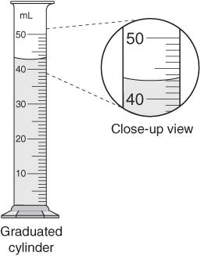

a) 41 mL

b) 42 mL

c) 43mL

d) 44mL

6. Which of the following observations are **quantitative**?

1. The candle has a greasy feel.
2. The rubbish bin has a strong odour.
3. The temperature of the water was measured at 37°C.
4. The soup is so hot that it hurts my teeth.

7. Which of the following is ***not*** a metric unit of measurement?

a) litre

b) kilometre

c) inch

d) gram

**For questions 8, 9 and 10 read the information below:**

A scientist was trying to see if the amount of water a plant gets affects plant growth. She collected 10 identical plants and gave them different amounts of water. She measured their growth daily. The plants received the same amount of sunlight.

8. What is the **independent** variable?

a) plant growth.

b) amount of sunlight.

c) amount of water.

d) 10 plants.

9. What is the **dependent** variable?

a) amount of sunlight

b) plant growth

c) growth measured daily

d) none of the above

10. What are the **controlled** variable(s)?

a) amount of sunlight

b) 10 identical plants

c) amount of water

d) both A and B

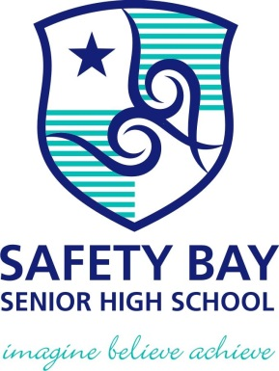

**SEMESTER ONE 2017**

**Transition Science Test:**

**ANSWER BOOKLET**

**NAME:**

**FORM:** **DATE:**

Multiple Choice Short Answer Total

**/31**

**/10**

**/41**

**SECTION ONE:** Multiple choice answers

Cross (X) through the correct answer.

|  |  |  |  |  |
| --- | --- | --- | --- | --- |
| **1** | a | b | c | d |
| **2** | a | b | c | d |
| **3** | a | b | c | d |
| **4** | a | b | c | d |
| **5** | a | b | c | d |
| **6** | a | b | c | d |
| **7** | a | b | c | d |
| **8** | a | b | c | d |
| **9** | a | b | c | d |
| **10** | a | b | c | d |

**SECTION TWO: Short Answer (30 marks)**

Answer the questions in the spaces provided.

1. Write two items that all students must use in the Science Laboratory to keep them safe, and how these items help to protect the students: (6 marks)

|  |  |
| --- | --- |
| **Item Name** | **How the item protects the student** |
|  |  |
|  |  |

1. State **two** metric units commonly used to measure: (6 marks)
   1. Distance
   2. Volume
   3. Mass
2. You are using a Bunsen burner to heat water in a beaker. Draw a **scientific diagram** to show how your equipment looks. You must use **proper 2D diagrams** and **label** all pieces of equipment. (8 marks)
3. Label the following statements as **observations** or **inferences**: (6 marks)
4. The liquid in the beaker is water
5. Steam is rising from the soup
6. The liquid in the beaker is colourless
7. The cat is meowing loudly
8. The soup is hot
9. The cat is hungry
10. What is the difference between *qualitative* and *quantitative* observations? Explain each one with the help of an example. (5 marks)

**END OF TEST**

**Please check your work!**